**Build and run an app**

Open the HelloToast app that you created previously.

1. Modify the **Toast** button so that it launches a new Activity to display the word "Hello!" and the current count, as shown below.
2. Change the text on the Toast button to **Say Hello**.

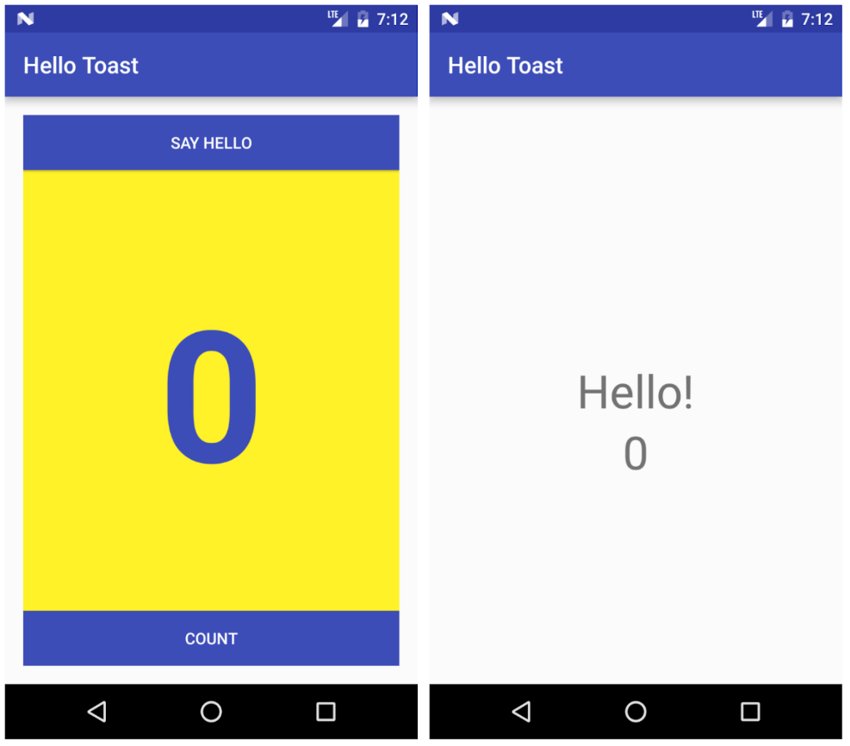

**Deliverables:**

Gather the following files into a ZIP file with your name somewhere in the file name:

● A zip file of your Android Studio project and include a screenshots folder containing snippets/screens of your app

● A word document explaining the steps you took to enhance the app, with screenshots, code added/modified, and step-by-step instructions similar to the format you see in the pre-req guide. You only have to document the enhancements part, which shouldn’t span more than 1-2 pages (unless your screen capture are large). Don’t stress too much about the documentation, just think if you were to give someone the enhancements guide you create, would they be able to enhance the app the same way successfully and with ease? Again, similar to the pre-req guide 😊

You may include the word document as part of your zip deliverable.

● Any other optional files specific to your application

Submit the ZIP file